**Experiment-6 : 4 bit LFSR**

**Objective:**

To design a 4 bit LFSR with characteristic polynomial 1+x3+x4  and to write a self checking test bench for it.

**Tool Used:**

Xilinx ISE.

**Theory:**

LFSR generates pseudo random output of size 2n-1. The output of register corresponding to the polynomial is XOR’d and fed into the input.

**DUT Code:**

module dff(input d,clk,set,output q);

    reg t;

    always@(posedge clk) begin

        if(set) t<=1'b1;

        else t <= d;

    end

    assign q = t;

endmodule

module lfsr(input clk,set,output [3:0]op);

    wire di;

    wire [3:0]q;

    assign di = q[3]^q[2];

    dff f1(di,clk,set,q[0]);

    dff f2(q[0],clk,set,q[1]);

    dff f3(q[1],clk,set,q[2]);

    dff f4(q[2],clk,set,q[3]);

    assign op = q;

endmodule

**TB Code:**

module tb;

    reg clk=0;

    reg set;

    reg [3:0]exp;

    wire [3:0]op;

    lfsr uut (clk,set,op);

    initial forever #5 clk = !clk;

initial begin

        set = 1;

        #20 set = 0;

        repeat(30)begin

            @(negedge clk);

            if(uut.q == exp) $display("success");

            else $display("failure");

            exp = uut.q;

            exp = {exp[2:0],exp[3]^exp[2]};

        end

    end

endmodule

**RTL Diagram:**

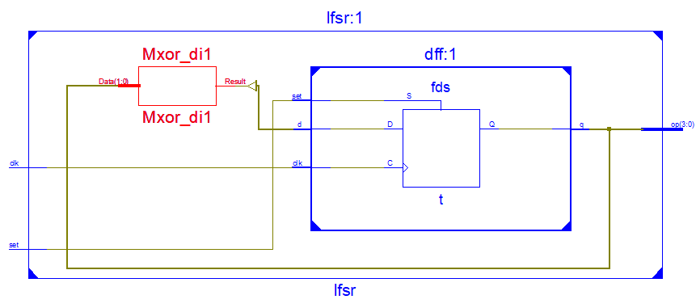

**Output Waveform:**

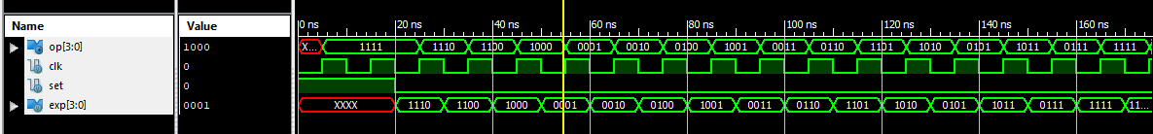

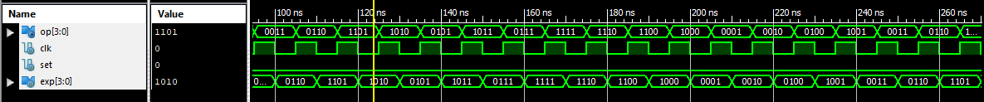

**Simulation Output:**

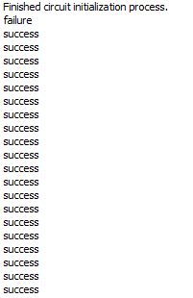

**Result:**

The simulation output and the RTL diagram is observed and found to be valid.